Feeling How One Wants to Feel May Be More Important in the USA Than in Japan
Supplemental Materials

Table of Contents
Measurement Invariance and Response Bias 2
Predicting Psychological Health Using Both Prohedonic and Contrahedonic Discrepancies 4
Response Surface Analyses 8
Results with Discrete Emotions 11

Measurement Invariance and Response Bias
We tested the measurement invariance of our psychological health measures, which included more than three items – the minimum required to assess invariance (Raubenheimer, 2004), using multiple-group multilevel confirmatory factor analysis. In three steps, we tested configural invariance (i.e., whether the same factor structure holds for both groups), metric invariance (i.e., whether the groups interpret the items in the same way), and scalar invariance (i.e., whether the two groups use the response scale in the same way, Putnick & Bornstein, 2016). Each step adds constraints to the previous model and is evaluated by comparing the fit of the more constrained model to that of the less constrained model from the previous step. We assessed three main goodness-of-fit indices: comparative fit index (CFI > .90), root mean square of error of approximation (RMSEA < .08), and standardized root mean square residual (SRMR < .08) – and used the majority rule to assess and compare models for configural, metric, and scalar equivalence.
Fit indices for multilevel multigroup confirmatory factor analyses are presented in Table S1, using maximum likelihood robust estimation. Using the majority rule, all of the invariance models demonstrated sufficient fitness to the data. Next, we tested measurement invariance, using the cutoff points for determining measurement invariance recommended by Putnick and Bornstein (2016). When testing for metric invariance, the cutoff points for the fit indices were △CFI ≤ −0.020, △RMSEA ≤ 0.015, and △SRMR ≤ 0.030. For scalar invariance, the cutoff points were △CFI ≤ −0.010, △RMSEA ≤ 0.015, and △SRMR ≤ 0.010. Furthermore, when scalar invariance was not supported, we examined the modification indices and relaxed the equality constraints on the items with two largest modification index values (i.e., purpose in life and physical health). Overall, these findings showed that the psychological health measures achieved partial metric invariance, rendering it appropriate to compare relationships between constructs across groups (e.g., Byrne et al., 1989).
Table S1
Summary of Fit Statistics for Testing Measurement Invariance of Psychological Health
 | CFI | RMSEA | SRMR | Model comparison | $△$CFI | $△$RMSEA | $△$SRMR | Invariant
Configural (M1) | 0.978 | 0.075 | 0.035 | - | - | - |  | -
Metric (M2) | 0.968 | 0.084 | 0.057 | M2-M1 | -0.010 | 0.008 | 0.022 | Yes
Scalar (M3) | 0.937 | 0.109 | 0.073 | M3-M2 | -0.031 | 0.025 | 0.016 | No
Partial scalar (M4) | 0.967 | 0.081 | 0.057 | M4-M2 | -0.001 | -0.002 | 0.000 | Yes

Next, we examined potential cultural differences in extreme response style – the frequency with which participants used the endpoints of a scale (Clarke, 2000). To detect potential extreme response patterns in our data, we summed all instances in which participants selected either endpoint of the rating scale (Harzing, 2006), including all items relevant to the current research question. There were no significant cultural differences in extreme responding between USA participants (M = 4.83, SD = 4.10) and Japanese participants (M = 4.51, SD = 4.80), p = .396, indicating that extremity bias are unlikely to account for our results. Therefore, we used raw scores in all subsequent analyses.

Predicting Psychological Health Using Both Prohedonic and Contrahedonic Discrepancies
Because the number of instances involving contrahedonic discrepancies was small, we could not test separately whether discrepancies – regardless of whether they were prohedonic or contrahedonic – were associated with poorer psychological health or whether these associations differed across cultures. Nonetheless, following Tamir et al. (2017) and the cybernetic prediction, if the direction of the discrepancy does not matter, then analyses using the full sample, which includes both prohedonic and contrahedonic discrepancies, should yield the same pattern of results. To corroborate our findings, we therefore repeated the key analyses reported in the main text using the full sample. Below, we report the results of the more restricted models with demographic covariates included as controls.
Well-being. The interaction between discrepancies and culture on well-being was significant for both unpleasant (p < .001) and pleasant (p = .009) emotions (see Table S2 and Figure S1). Larger discrepancies were associated with lower well-being among USA participants, for both unpleasant emotions, B = -0.11, SE = 0.02, p < .001, 95% CI [-0.14, -0.07], and pleasant emotions, B = -0.05, SE = 0.02, p = .002, 95% CI [-0.08, -0.02]. However, these associations were not significant among Japanese participants, for both unpleasant emotions, B = -0.02, SE = 0.02, p = .283, 95% CI [-0.06, 0.02], and pleasant emotions, B = 0.01, SE = 0.02, p = .640, 95% CI [-0.03, 0.04]. The main effect of discrepancies was significant for unpleasant emotions (p < .001), but not significant for pleasant emotions (p = .121), indicating that, on average, feeling undesired unpleasant emotions was associated with lower well-being. The main effect of culture was not significant for either unpleasant or pleasant emotions (ps $≥$ .240).
Psychological Distress. Links between discrepancies and psychological distress did not differ by culture, as evidenced by non-significant interactions for both unpleasant (p = .321) and pleasant emotions (p = .141). The main effect of discrepancies was significant for both unpleasant emotions (p = .039) and pleasant emotions (p < .001), such that larger discrepancies between experienced and desired emotions were generally linked to greater psychological distress. The main effect of culture was significant for both unpleasant and pleasant emotions (ps $≤$ .033), such that Japanese (vs. USA) participants reported greater daily psychological distress.
Overall, these findings were similar to those reported in the main text and provide further evidence that discrepancies, regardless of their direction, were associated with poorer psychological health and that these associations differed between Japan and USA.

Table S2
Fixed Effects from Multilevel Models: Examining Whether Discrepancies between Experienced and Desired Emotions Were Linked to Psychological Health (i.e. Well-being and Psychological Distress) in the USA and Japan
 | Well-being |  |  |  |  | Psychological distress
Variables | B (SE) | p | $$β$$  95% CI | R² |  | B (SE) | p | $$β$$  95% CI | R²
Unpleasant emotions (UE)
Level 1 variables
(Intercept) | 5.76 (0.10) | < .001 | 0.00  [-0.12, 0.12] | - |  | 3.15 (0.11) | < .001 | 0.03  [-0.09, 0.14] | -
Discrepancies in UE | -0.06 (0.02) | < .001 | -0.06  [-0.08, -0.03] | .004 |  | 0.05 (0.02) | .039 | 0.03  [0.00, 0.06] | .001
Experienced UE | -0.12 (0.01) | < .001 | -0.11  [-0.13, -0.09] | .015 |  | 0.30 (0.01) | < .001 | 0.22  [0.20, 0.24] | .059
Desired UE | -0.02 (0.02) | .309 | -0.01  [-0.03, 0.01] | .000 |  | 0.12 (0.02) | < .001 | 0.06  [0.04, 0.08] | .013
Level 2 variables
Culture | -0.13 (0.11) | .240 | -0.08  [-0.22, 0.06] | .018 |  | -0.27 (0.13) | .033 | -0.14  [-0.27, -0.01] | .047
Gender | -0.15 (0.12) | .207 | -0.09  [-0.23, 0.05] | .021 |  | 0.09 (0.13) | .483 | 0.05  [-0.08, 0.17] | .005
Age | -0.09 (0.07) | .178 | -0.08  [-0.20, 0.04] | .023 |  | 0.12 (0.08) | .130 | 0.08  [-0.02, 0.19] | .023
Compliance | 0.02 (0.01) | .013 | 0.11  [0.02, 0.20] | .044 |  | -0.02 (0.01) | .008 | -0.11  [-0.19, -0.03] | .041
Cross-level interaction
Discrepancies $×$Culture | -0.04 (0.01) | < .001 | -0.04  [-0.06, -0.02] | .004 |  | -0.02 (0.02) | .321 | -0.01  [-0.04, 0.01] | .001
Pleasant emotions (PE)
Level 1 variables
(Intercept) | 5.76 (0.10) | < .001 | 0.00  [-0.12, 0.12] | - |  | 3.15 (0.11) | < .001 | 0.03  [-0.09, 0.14] | -
Discrepancies in PE | -0.02 (0.01) | .121 | -0.02  [-0.04, 0.00] | .001 |  | 0.07 (0.02) | < .001 | 0.05  [0.02, 0.08] | .004
Experienced PE | 0.20 (0.01) | < .001 | 0.19  [0.17, 0.20] | .074 |  | -0.17 (0.01) | < .001 | -0.13  [-0.15, -0.11] | .029
Desired PE | 0.08 (0.01) | < .001 | 0.06  [0.04, 0.08] | .011 |  | 0.00 (0.02) | .870 | 0.00  [-0.02, 0.03] | .000
Level 2 variables
Culture | -0.12 (0.11) | .267 | -0.08  [-0.22, 0.06] | .017 |  | -0.30 (0.13) | .017 | -0.16  [-0.29, -0.03] | .049
Gender | -0.13 (0.11) | .261 | -0.08  [-0.22, 0.06] | .018 |  | 0.09 (0.13) | .464 | 0.05  [-0.08, 0.18] | .005
Age | -0.09 (0.07) | .203 | -0.07  [-0.19, 0.04] | .021 |  | 0.13 (0.08) | .099 | 0.09  [-0.02, 0.20] | .023
Compliance | 0.02 (0.01) | .017 | 0.11  [0.02, 0.19] | .043 |  | -0.02 (0.01) | .005 | -0.12  [-0.20, -0.04] | .040
Cross-level interaction
Discrepancies $×$Culture | -0.03 (0.01) | .009 | -0.02  [-0.04, -0.01] | .002 |  | 0.03 (0.02) | .141 | 0.02  [-0.01, 0.04] | .001
Note. Results included the entire sample. Culture: Japan = -1, USA = 1. Gender: -1 = female or other gender identities, 0 = unknown, 1 = male. B (SE) = raw regression coefficient (standard error). $β$, 95% CI = standardized coefficient and its 95% confidence interval.

Figure S1
Daily Well-being Varied as a Function of Culture and Discrepancies between Experienced and Desired Emotions
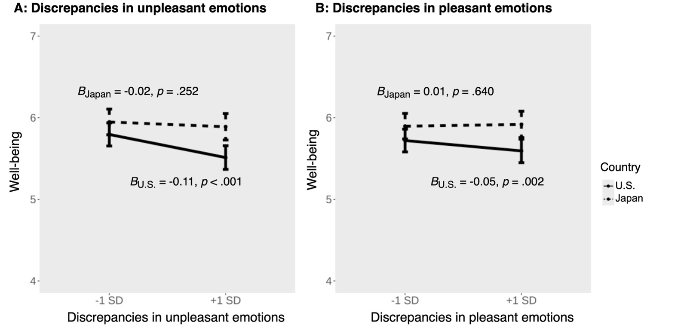

Response Surface Analyses
Results from difference score analyses supported our hypothesis that discrepancies between experienced and desired emotions are differentially linked to motivation in emotion regulation in the USA and Japan. To corroborate our findings, we conducted a multilevel response surface analysis (RSA; Nestler et al., 2019), using the RSA package in R (Nestler et al., 2019; Schönbrodt & Humberg, 2021). RSA presents an alternative approach to examine the degree to which the congruence and incongruence of two variables is linked to an outcome (e.g., Shanock et al., 2010).
Following Nestler et al (2019), first, we centered the two predictors (experienced emotions and desired emotions) around the grand mean across both variables. Then, five variables were entered as predictors in a multilevel polynomial regression in the following order: (1) experienced emotions (b₁), (2) desired emotions (b₂), (3) a quadratic term for experienced emotions (b₃), (4) an “experienced emotions$×$ desired emotions” interaction term (b₄), and (5) a quadratic term for desired emotions (b₅). We used these five variables to predict prohedonic motivation in emotion regulation in a multilevel model, focusing on instances where participants reported feeling more unpleasant or less pleasant than they desired. We included random intercepts and slopes for experienced and desired emotions. In some models (e.g., predicting motivation to decrease unpleasant emotions among USA sample), to facilitate model convergence, additional random slope(s) that explained the least amount of variance were dropped. Next, estimated regression coefficients from the multilevel polynomial regression (b₁-b₅) were used to derive the response surface parameters (a₁-a₄). We conducted this analysis separately for the USA and Japan samples, and we repeated the RSA for both pleasant and unpleasant emotions.
Our interpretation focuses on the response surface parameters and whether the RSA results were consistent with the results reported in the main text.
Motivation in Prohedonic Emotion Regulation
When assessing prohedonic motivation in emotion regulation, we focused on the effect of incongruence (i.e., not feeling right), which was assessed by calculating a₃ = b₁ - b₂ (Shanock et al., 2010). This parameter captures how the outcome changes when the predictors deviate from each other in opposite directions. A positive a₃ indicates that when the rating of experienced emotions is larger than the rating of desired emotions, the outcome (e.g., motivation) increases as the discrepancy increases. A negative a₃ indicates that when the rating of desired emotions is larger than the rating of experienced emotions, the outcome increases as the discrepancy increases.
As Table S3 shows, among USA participants, the a₃ parameter was significant for both pleasant and unpleasant emotions. Specifically, when desired pleasant emotions exceeded experienced pleasant emotions, participants from the USA were more motivated to increase pleasant emotions. In contrast, when experienced unpleasant emotions exceeded desired unpleasant emotions, they were more motivated to decrease unpleasant emotions.
Among Japanese participants, consistent with results in the main text, the a₃ parameter was not significant for unpleasant emotions. Different from results in the main text, the a₃ parameter was significant for pleasant emotions, suggesting that when desired pleasant emotions exceeded experienced pleasant emotions, participants from Japan were also more motivated to increase pleasant emotions. Nonetheless, although we were not able to statistically compare the strength of the coefficients between the two groups, the RSA results potentially support our hypothesis that emotional incongruence is more strongly associated with the initiation of emotion regulation goals among USA (vs. Japanese) participants (USA: a₃ = -0.58; Japan: a₃ = -0.38).
Table S3.
Response Surface Analysis Predicting Prohedonic Motivation in Emotion Regulation
 |  | USA |  | Japan
 |  | Pleasant emotions | Unpleasant emotions | Pleasant emotions | Unpleasant emotions
 |  | coefficient (se) | coefficient (se) | coefficient (se) | coefficient (se)
Multilevel polynomial regression coefficients
b₁ – experienced emotion |  | -0.11 (0.04)** | 0.30 (0.05)*** | 0.05 (0.04) | 0.20 (0.06)***
b₂ – desired emotion |  | 0.46 (0.05)*** | -0.09 (0.08) | 0.43 (0.05)*** | 0.08 (0.07)
b₃ – experienced emotion² |  | -0.02 (0.01)* | -0.01 (0.01) | 0.01 (0.01) | 0.00 (0.01)
b₄ – experienced emotion $×$desired emotion |  | -0.02 (0.01) | -0.03 (0.02) | 0.01 (0.02) | -0.04 (0.03)
b₅ – desired emotion² |  | 0.01 (0.01) | 0.01 (0.02) | 0.01 (0.01) | 0.05 (0.02)*
Response surface parameters
a₁ – slope along LOC |  | 0.35 (0.04)*** | 0.21 (0.05)** | 0.47 (0.03)*** | 0.28 (0.06)***
a₂ – curvature along LOC |  | -0.03 (0.01)** | -0.04 (0.02) | 0.04 (0.01)*** | 0.01 (0.02)
a₃ – slope along LOIC |  | -0.58 (0.08)*** | 0.40 (0.12)** | -0.38 (0.09)*** | 0.11 (0.11)
a₄ – curvature along LOIC |  | 0.01 (0.03) | 0.03 (0.05) | 0.01 (0.03) | 0.09 (0.05)
Note. LOC = line of congruence; LOIC = line of incongruence. a₁ (the slope of LOC) tests whether motivation in emotion regulation was higher when participants’ experienced and desired emotions agreed at a higher level. a₂ tests whether the LOC has a linear or curvilinear shape. a₃ (the slope of LOIC) tests whether motivation in emotion regulation was higher when experienced and desired emotions were in greater disagreement (i.e., larger discrepancies). And a₄ tests whether the LOIC has a linear or curvilinear shape. *p < .05, **p < .01, ***p < .001.

Results with Discrete Emotions
In the key analyses, we focus on valence-based comparisons. Nonetheless, it is important to test cultural differences as a function of both valence and arousal (Tsai, 2007). To this end, we tested whether the predicted associations with motivation to engage in prohedonic emotion regulation (focusing on prohedonic discrepancies) and with psychological health (focusing on both prohedonic and contrahedonic discrepancies) differed as a function of valence and arousal.
As predicted, we observed the same pattern of results for well-being (see Table S5 and Figure S3), such that larger discrepancies were negatively associated with well-being among Americans but unrelated to well-being among Japanese participants. Similar to the valence-based analyses, we found no culture $×$ discrepancy interaction on psychological distress, except for high arousal pleasant emotions (see Table S6). Specifically, larger discrepancies between experienced and desired high arousal pleasant emotions were linked to greater psychological distress among Americans (B = 0.08, SE = 0.02, p < .001) but unrelated to psychological distress among Japanese (B = 0.02, SE = 0.02, p = .416). This pattern is consistent with our theoretical prediction that discrepancies between experienced and desired emotions would be more important for Americans than for Japanese.
With respect to motivation (see Table S4), we observed a similar pattern of results for both low and high pleasant emotions, such that larger discrepancies were associated with a stronger motivation in both counties, but as expected, this association was stronger among Americans than among Japanese (see Figure S2); and this pattern was observed for both low-arousal and high-arousal pleasant emotions. When we looked at unpleasant emotions, unlike the combined valence-based composite, when separating discrepancies by arousal, discrepancies × culture interactions did not reach statistical significance for either low-arousal or high-arousal unpleasant emotions. We speculate that the differences between the composite score and the discrete emotion scores may have arisen because the discrepancy-motivation association among Japanese was weaker. As a result, when looking at individual items, the association may have fallen below the threshold for statistical significance, even though the direction of the relationship was similar. Given the similarities and differences with valence-based analyses, future research should test whether cultural differences in the implications of discrepancies are more pronounced for certain emotions.

Table S4 Fixed Effects from Multilevel Models: Examining Whether Discrepancies Between Experienced and Desired Emotions (by Valence and Arousal) Were Linked to Motivation in Prohedonic Emotion Regulation in the USA and Japan
Variables | B (SE) | p | $$β$$  95% CI | R² |  |  |  | B (SE) | p | $$β$$  95% CI | R²
Variables | Increasing low-arousal pleasant emotions |  |  |  |  |  | Increasing high-arousal pleasant emotions
Level 1 variables
(Intercept) | 6.87 (0.12) | < .001 | -0.02  [-0.11, 0.07] | - |  |  |  | 6.69 (0.13) | < .001 | -0.03  [-0.12, 0.06] | -
Discrepancies | 0.81 (0.10) | < .001 | 0.70  [0.53, 0.88] | 0.13 |  |  |  | 1.01 (0.12) | < .001 | 0.82  [0.63, 1.02] | 0.16
Experienced emotion | 0.75 (0.10) | < .001 | 0.67  [0.49, 0.85] | 0.12 |  |  |  | 1.02 (0.12) | < .001 | 0.91  [0.69, 1.12] | 0.16
Desired emotion | -0.45 (0.10) | < .001 | -0.27  [-0.40, -0.15] | 0.04 |  |  |  | -0.65 (0.12) | < .001 | -0.42  [-0.58, -0.26] | 0.07
Level 2 variables
Culture | 0.26 (0.10) | .013 | 0.13  [0.03, 0.23] | 0.02 |  |  |  | 0.07 (0.10) | .516 | 0.03  [-0.07, 0.13] | 0.00
Gender | 0.15 (0.10) | .136 | 0.08  [-0.02, 0.18] | 0.01 |  |  |  | 0.13 (0.10) | .219 | 0.06  [-0.04, 0.16] | 0.01
Age | 0.01 (0.06) | .885 | 0.01  [-0.08, 0.09] | 0.00 |  |  |  | -0.03 (0.06) | .614 | -0.02  [-0.11, 0.06] | 0.00
Compliance | -0.01 (0.01) | .287 | -0.04  [-0.10, 0.03] | 0.00 |  |  |  | -0.01 (0.01) | .120 | -0.05  [-0.12, 0.01] | 0.01
Cross-level interaction
Discrepancies$×$ Culture | 0.05 (0.01) | < .001 | 0.04  [0.02, 0.06] | 0.00 |  |  |  | 0.05 (0.01) | < .001 | 0.04  [0.02, 0.06] | 0.00
 | Decreasing low-arousal unpleasant emotions |  |  |  |  |  |  | Decreasing high-arousal unpleasant emotions
Level 1 variables
(Intercept) | 5.07 (0.17) | < .001 | 0.02  [-0.08, 0.12] | - |  |  |  | 5.37 (0.17) | < .001 | 0.02  [-0.08, 0.13] | -
Discrepancies | -0.61 (0.22) | .006 | -0.38  [-0.65, -0.11] | 0.02 |  |  |  | -0.14 (0.23) | .550 | -0.08  [-0.37, 0.20] | 0.00
Experienced emotion | 0.82 (0.22) | < .001 | 0.53  [0.25, 0.81] | 0.04 |  |  |  | 0.42 (0.23) | .071 | 0.27  [-0.02, 0.57] | 0.01
Desired emotion | -0.65 (0.22) | .004 | -0.21  [-0.35, -0.07] | 0.03 |  |  |  | -0.27 (0.23) | .255 | -0.09  [-0.24, 0.06] | 0.01
Level 2 variables
Culture | 0.48 (0.15) | .001 | 0.18  [0.07, 0.29] | 0.05 |  |  |  | 0.46 (0.15) | .002 | 0.17  [0.06, 0.28] | 0.05
Gender | 0.10 (0.14) | .477 | 0.04  [-0.06, 0.14] | 0.00 |  |  |  | 0.10 (0.13) | .464 | 0.04  [-0.06, 0.13] | 0.00
Age | 0.13 (0.08) | .115 | 0.07  [-0.02, 0.16] | 0.01 |  |  |  | 0.07 (0.08) | .377 | 0.04  [-0.04, 0.12] | 0.00
Compliance | -0.00 (0.01) | .949 | -0.00  [-0.07, 0.07] | 0.00 |  |  |  | 0.01 (0.01) | .295 | 0.03  [-0.03, 0.10] | 0.00
Cross-level interaction
Discrepancies$×$ Culture | 0.03 (0.02) | .086 | 0.02  [0.00, 0.04] | 0.00 |  |  |  | 0.04 (0.02) | .085 | 0.02  [0.00, 0.05] | 0.00
Note.: Results included instances of prohedonic discrepancies. Japan = -1, USA = 1. Gender: -1 = female or other gender identities, 0 = unknown, 1 = male. B (SE) = raw regression coefficient (standard error). $β$, 95% CI = standardized coefficient and its 95% confidence interval.

Figure S2
Motivation in Prohedonic Emotion Regulation as a Function of Culture and Discrepancies Between Experienced and Desired Emotions (by Valence and Arousal)
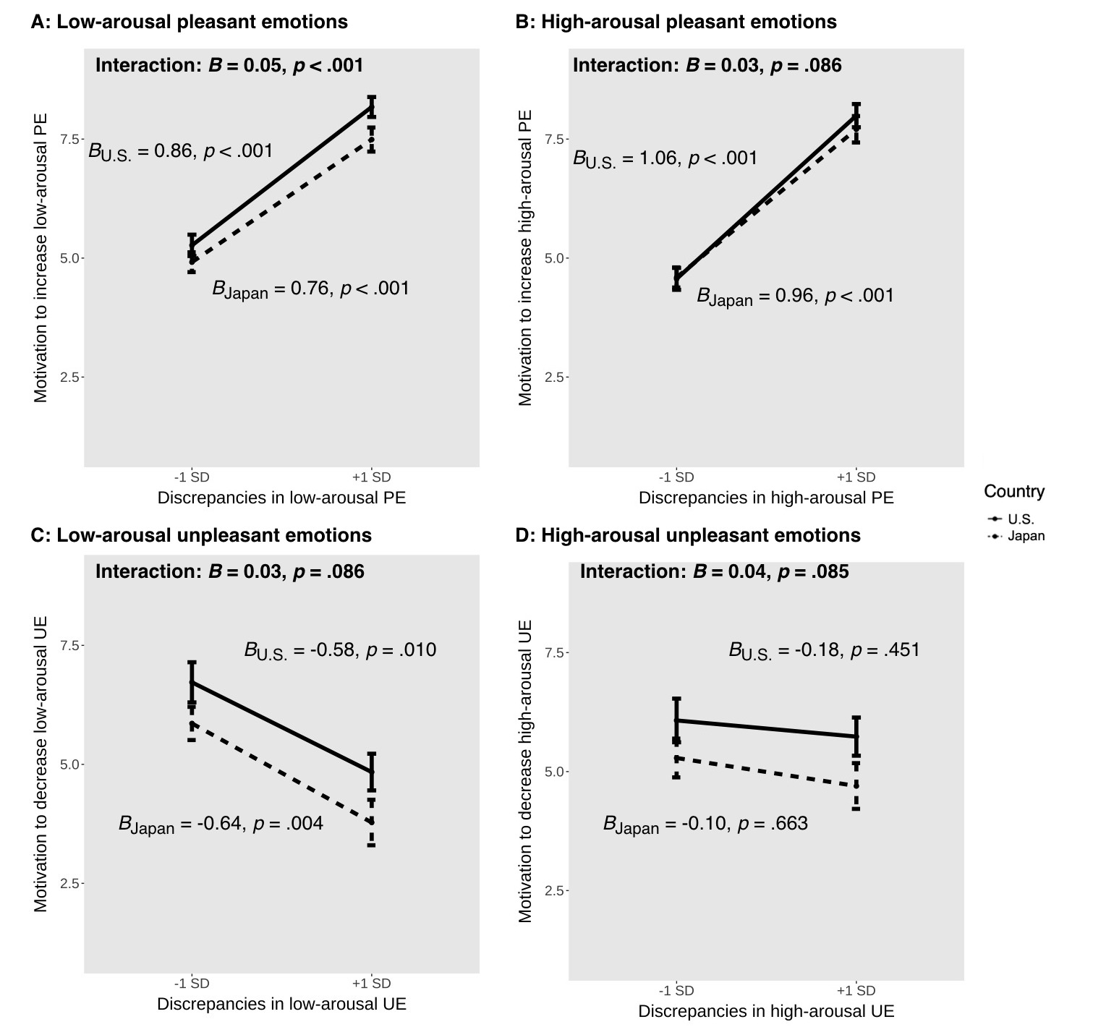

Table S5
Fixed Effects from Multilevel Models: Examining Whether Discrepancies Between Experienced and Desired Emotions (by Valence and Arousal) Were Linked to Well-being in the USA and Japan
Variables | B (SE) | p | $$β$$  95% CI | R² |  |  |  | B (SE) | p | $$β$$  95% CI | R²
Variables | Low-arousal pleasant emotions |  |  |  |  |  | High-arousal pleasant emotions
Level 1 variables
(Intercept) | 5.76 (0.10) | < .001 | 0.00  [-0.12, 0.12] | - |  |  |  | 5.76 (0.10) | < .001 | 0.00  [-0.12, 0.12] | -
Discrepancies | -0.02 (0.01) | .114 | -0.02  [-0.04, 0.00] | 0.00 |  |  |  | -0.03 (0.01) | .005 | -0.03  [-0.05, -0.01] | 0.00
Experienced emotion | 0.12 (0.01) | < .001 | 0.13  [0.12, 0.15] | 0.04 |  |  |  | 0.14 (0.01) | < .001 | 0.16  [0.14, 0.18] | 0.05
Desired emotion | 0.04 (0.01) | .001 | 0.04  [0.02, 0.06] | 0..01 |  |  |  | 0.07 (0.01) | < .001 | 0.07  [0.04, 0.09] | 0.01
Level 2 variables
Culture | -0.13 (0.11) | .244 | -0.08  [-0.22, 0.06] | 0.02 |  |  |  | -0.11 (0.11) | .333 | -0.07  [-0.21, 0.07] | 0.01
Gender | -0.14 (0.11) | .221 | -0.09  [-0.22, 0.05] | 0.02 |  |  |  | -0.13 (0.11) | .244 | -0.08  [-0.22, 0.06] | 0.02
Age | -0.09 (0.07) | .178 | -0.08  [-0.19, 0.04] | 0.02 |  |  |  | -0.09 (0.07) | .182 | -0.08  [-0.19, 0.04] | 0.02
Compliance | 0.02 (0.01) | .012 | 0.11  [0.02, 0.20] | 0.04 |  |  |  | 0.02 (0.01) | .012 | 0.11  [0.03, 0.20] | 0.05
Cross-level interaction
Discrepancies$×$ Culture | -0.02 (0.01) | .003 | -0.03  [-0.04, -0.01] | 0.00 |  |  |  | -0.03 (0.01) | .002 | -0.03  [-0.04, -0.01] | 0.00
 | Low-arousal unpleasant emotions |  |  |  |  |  |  | High-arousal unpleasant emotions
Level 1 variables
(Intercept) | 5.76 (0.10) | < .001 | 0.00  [-0.12, 0.13] | - |  |  |  | 5.76 (0.10) | < .001 | 0.00  [-0.12, 0.12] | -
Discrepancies | -0.05 (0.01) | < .001 | -0.06  [-0.08, -0.03] | 0.00 |  |  |  | -0.03 (0.01) | .015 | -0.03  [-0.06, -0.01] | 0.00
Experienced emotion | -0.08 (0.01) | < .001 | -0.08  [-0.10, -0.06] | 0.01 |  |  |  | -0.09 (0.01) | < .001 | -0.09  [-0.11, -0.07] | 0.02
Desired emotion | -0.03 (0.01) | .042 | -0.02  [-0.04, 0.00] | 0.00 |  |  |  | -0.01 (0.01) | .403 | -0.01  [-0.03, 0.01] | 0.00
Level 2 variables
Culture | -0.13 (0.11) | .259 | -0.08  [-0.22, 0.06] | 0.02 |  |  |  | -0.13 (0.11) | .242 | -0.08  [-0.22, 0.06] | 0.02
Gender | -0.14 (0.12) | .226 | -0.09  [-0.22, 0.05] | 0.02 |  |  |  | -0.14 (0.12) | .218 | -0.09  [-0.23, 0.05] | 0.02
Age | -0.10 (0.07) | .156 | -0.08  [-0.20, 0.03] | 0.02 |  |  |  | -0.09 (0.07) | .187 | -0.08  [-0.19, 0.04] | 0.02
Compliance | 0.02 (0.01) | .011 | 0.11  [0.03, 0.20] | 0.05 |  |  |  | 0.02 (0.01) | .012 | 0.11  [0.02, 0.20] | 0.04
Cross-level interaction
Discrepancies$×$ Culture | -0.03 (0.01) | .002 | -0.03  [-0.05, -0.01] | 0.00 |  |  |  | -0.02 (0.01) | .008 | -0.03  [-0.05, -0.01] | 0.00
Note.: Results included the entire sample. Japan = -1, USA = 1. Gender: -1 = female or other gender identities, 0 = unknown, 1 = male. B (SE) = raw regression coefficient (standard error). $β$, 95% CI = standardized coefficient and its 95% confidence interval.

Figure S3
Well-being as a Function of Culture and Discrepancies Between Experienced and Desired Emotions (by Valence and Arousal)

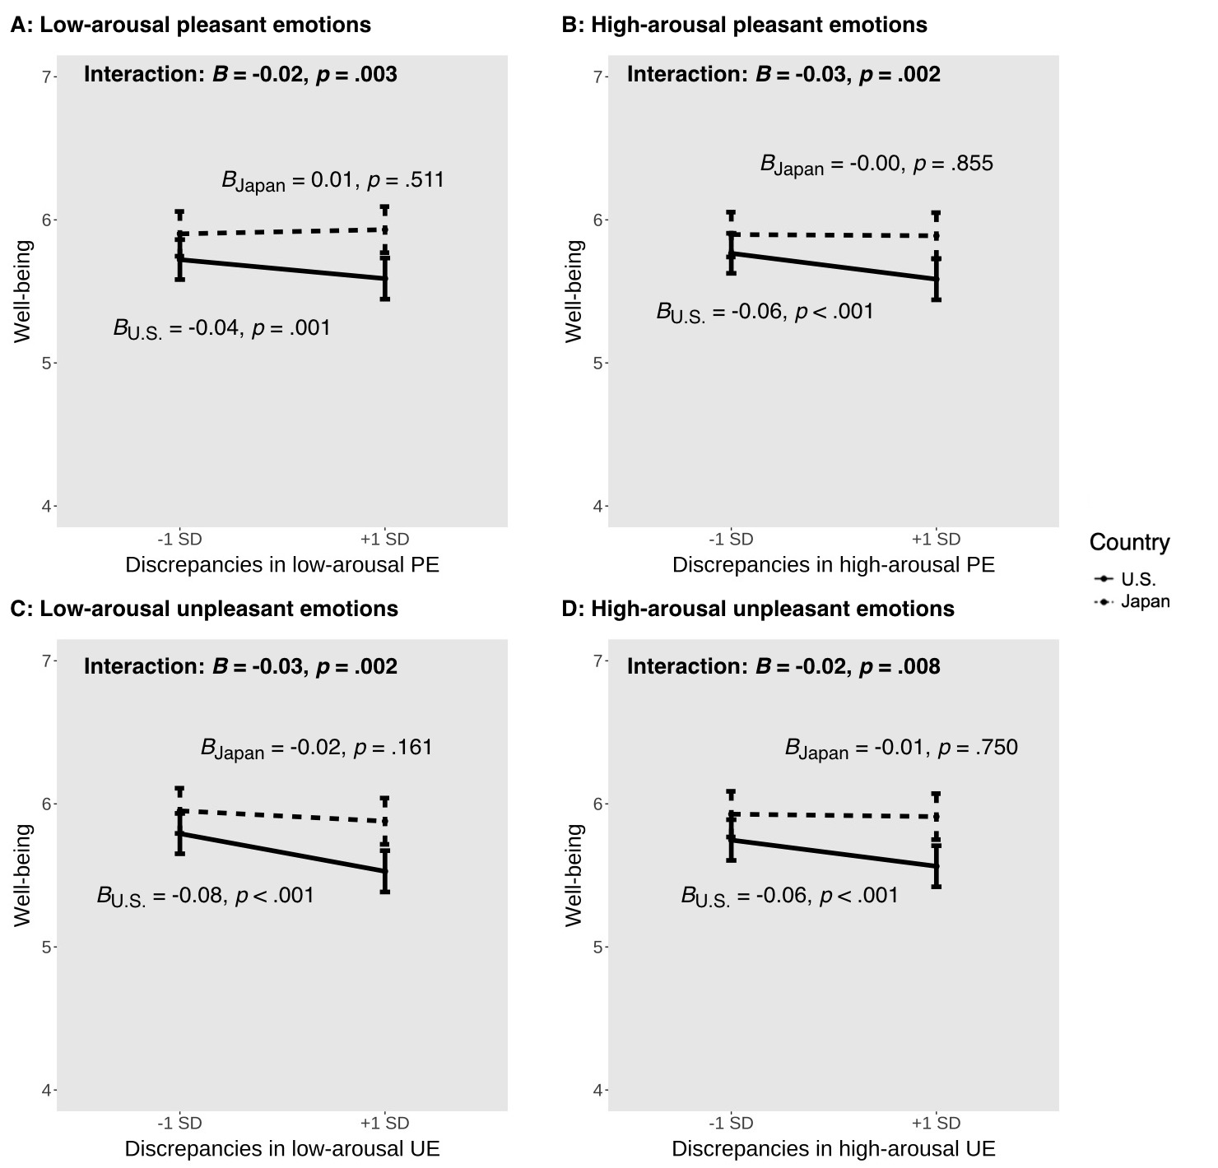
Table S6
Fixed Effects from Multilevel Models: Examining Whether Discrepancies Between Experienced and Desired Emotions Were (by Valence and Arousal) Linked to Psychological Distress in the USA and Japan
Variables | B (SE) | p | $$β$$  95% CI | R² |  |  |  | B (SE) | p | $$β$$  95% CI | R²
Variables | Low-arousal pleasant emotions |  |  |  |  |  | High-arousal pleasant emotions
Level 1 variables
(Intercept) | 3.15 (0.11) | < .001 | 0.02  [-0.09, 0.14] | - |  |  |  | 3.15 (0.11) | < .001 | 0.02  [-0.09, 0.14] | -
Discrepancies | 0.07 (0.02) | < .001 | 0.06  [0.03, 0.09] | 0.01 |  |  |  | 0.05 (0.02) | .003 | 0.04  [0.02, 0.07] | 0.00
Experienced emotion | -0.10 (0.01) | < .001 | -0.10  [-0.11, -0.08] | 0.02 |  |  |  | -0.12 (0.01) | < .001 | -0.12  [-0.14, -0.10] | 0.02
Desired emotion | 0.01 (0.02) | .726 | 0.00  [-0.02, 0.03] | 0.00 |  |  |  | -0.01 (0.02) | .669 | -0.01  [-0.03, 0.02] | 0.00
Level 2 variables
Culture | -0.29 (0.13) | .024 | -0.15  [-0.28, -0.02] | 0.04 |  |  |  | -0.29 (0.12) | .021 | -0.15  [-0.28, -0.02] | 0.04
Gender | 0.10 (0.13) | .461 | 0.05  [-0.08, 0.18] | 0.01 |  |  |  | 0.11 (0.13) | .379 | 0.06  [-0.07, 0.19] | 0.01
Age | 0.12 (0.08) | .127 | 0.08  [-0.02, 0.19] | 0.02 |  |  |  | 0.15 (0.08) | .059 | 0.10  [0.00, 0.21] | 0.03
Compliance | -0.02 (0.01) | .004 | -0.12  [-0.20, -0.04] | 0.04 |  |  |  | -0.02 (0.01) | .004 | -0.12  [-0.20, -0.04] | 0.04
Cross-level interaction
Discrepancies$×$ Culture | 0.03 (0.01) | .079 | 0.02  [0.00, 0.05] | 0.00 |  |  |  | 0.03 (0.01) | .038 | 0.02  [0.00, 0.05] | 0.00
 | Low-arousal unpleasant emotions |  |  |  |  |  |  | High-arousal unpleasant emotions
Level 1 variables
(Intercept) | 3.15 (0.11) | < .001 | 0.02  [-0.09, 0.14] | - |  |  |  | 3.15 (0.11) | < .001 | 0.03  [-0.09, 0.14] | -
Discrepancies | 0.02 (0.02) | .235 | 0.02  [-0.01, 0.05] | 0.00 |  |  |  | 0.02 (0.02) | .175 | 0.02  [-0.01, 0.05] | 0.00
Experienced emotion | 0.22 (0.01) | < .001 | 0.19  [0.17, 0.21] | 0.05 |  |  |  | 0.22 (0.01) | < .001 | 0.20  [0.17, 0.22] | 0.05
Desired emotion | 0.11 (0.02) | < .001 | 0.07  [0.05, 0.09] | 0.02 |  |  |  | 0.09 (0.02) | < .001 | 0.06  [0.03, 0.08] | 0.01
Level 2 variables
Culture | -0.27 (0.13) | .035 | -0.14  [-0.27, -0.01] | 0.04 |  |  |  | -0.23 (0.13) | .070 | -0.12  [-0.25, 0.01] | 0.03
Gender | 0.12 (0.13) | .353 | 0.06  [-0.07, 0.19] | 0.01 |  |  |  | 0.09 (0.13) | .463 | 0.05  [-0.08, 0.18] | 0.01
Age | 0.12 (0.08) | .123 | 0.08  [-0.02, 0.19] | 0.02 |  |  |  | 0.12 (0.08) | .126 | 0.08  [-0.02, 0.19] | 0.02
Compliance | -0.03 (0.01) | .003 | -0.12  [-0.20, -0.04] | 0.05 |  |  |  | -0.02 (0.01) | .009 | -0.11  [-0.19, -0.03] | 0.04
Cross-level interaction
Discrepancies$×$ Culture | -0.01 (0.02) | .481 | -0.01  [-0.03, 0.02] | 0.00 |  |  |  | -0.02 (0.01) | .182 | -0.02  [-0.04, 0.01] | 0.00
Note.: Results included the entire sample. Japan = -1, USA = 1. Gender: -1 = female or other gender identities, 0 = unknown, 1 = male. B (SE) = raw regression coefficient (standard error). $β$, 95% CI = standardized coefficient and its 95% confidence interval.

